LAB - 12

|  |  |
| --- | --- |
| Name | Keval D Gandevia |
| Roll Number | CE046 |
| ID | 19CEUEG017 |
| Subject | Image Processing |

**Aim:** Performing Image Segmentation

**Q. 1: Apply laplacian mask [-1 -1 -1;-1 8 -1;-1 -1 -1] to the ‘wirebond.tif’ image and get the following images. (use conv2 and imfilter to filter the images and see the difference). a. Laplacian of the image. b. Absolute value of the laplacian. c. Positive values of the laplacian.**

* **Code:**

|  |
| --- |
| img = imread('wirebond.tif');  [m, n] = size(img);  figure;  imshow(img);  mask = [-1 -1 -1;-1 8 -1;-1 -1 -1];  laplacianImg = conv2(img, mask);  % filterredImg = imfilter(img, mask);  figure;  imshow(laplacianImg, []);  figure;  imshow(abs(laplacianImg));  for i = 1 : m  for j = 1 : n  if(laplacianImg(i, j) < 0)  new_img(i, j) = 0;  else  new_img(i, j) = laplacianImg(i, j);  end  end  end  figure;  imshow(new_img); |

* **Output:**
* **Original Image:**

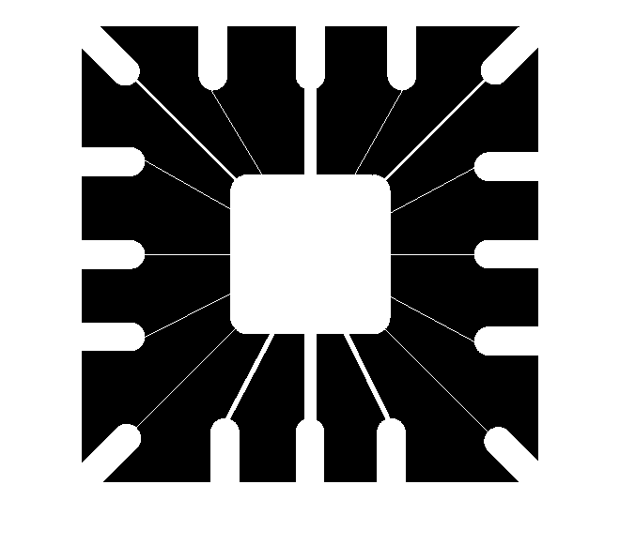

* 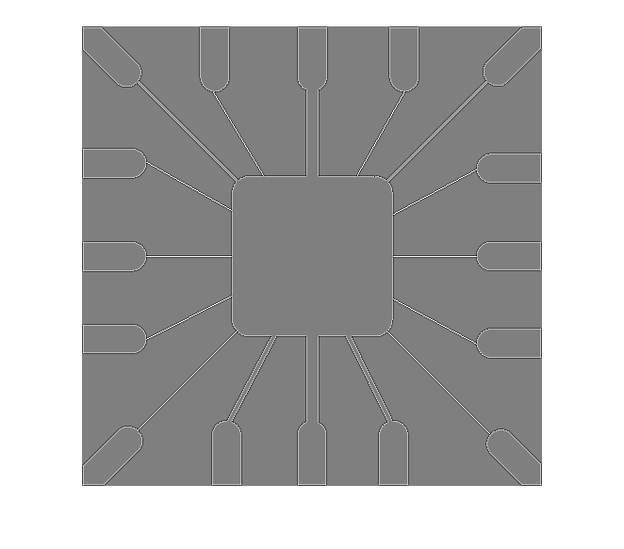**Laplacian of the image:**
* **Absolute value of Laplacian:**

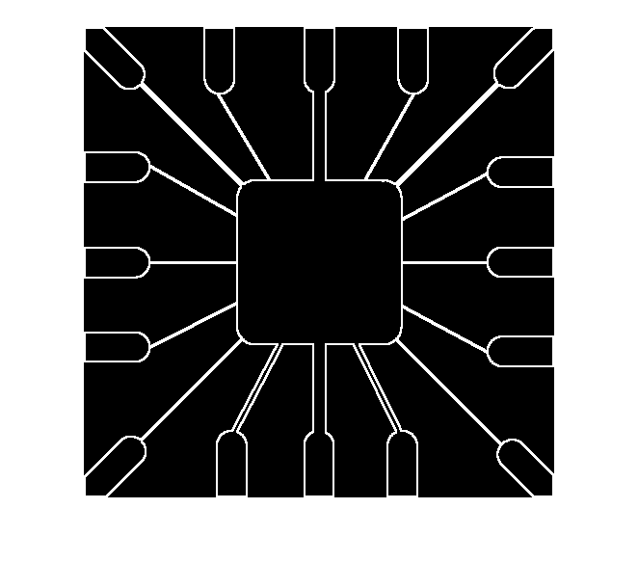

* 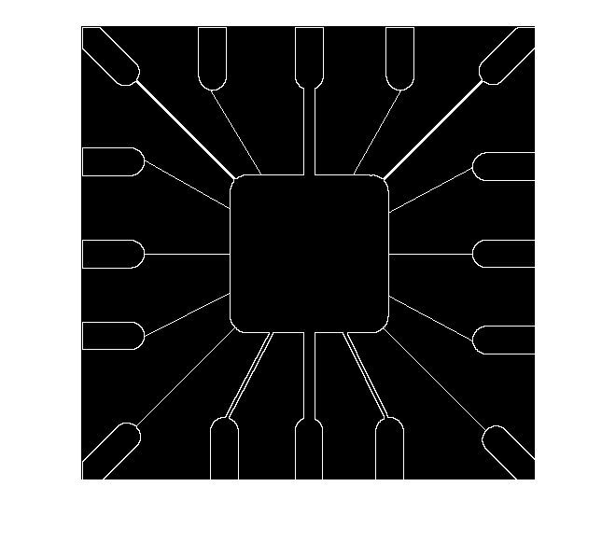**Positive Values of Laplacian:**

**Q. 2: Apply gradient filter (Sobel filter) to the image ‘building.tif’ and output a. Gradient in x direction b. Gradient in y direction c. Absolute Gradient.**

* **Code:**

|  |
| --- |
| img = imread('building.tif');  figure;  imshow(img);  gx = [1 2 1; 0 0 0; -1 -2 -1];  gy = [-1 0 1; -2 0 2; -1 0 1];  xImg = imfilter(img, gx);  yImg = imfilter(img, gy);  magnitude = xImg + yImg;  figure;  imshow(xImg);  figure;  imshow(yImg);  figure;  imshow(magnitude); |

* **Output:**
* 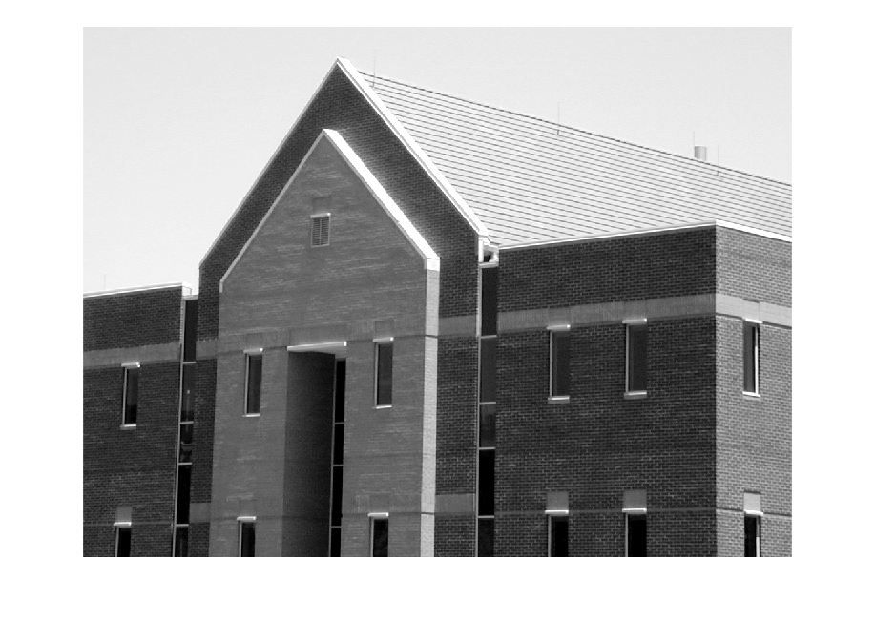**Original Image:**
* **Gradient in x direction:**

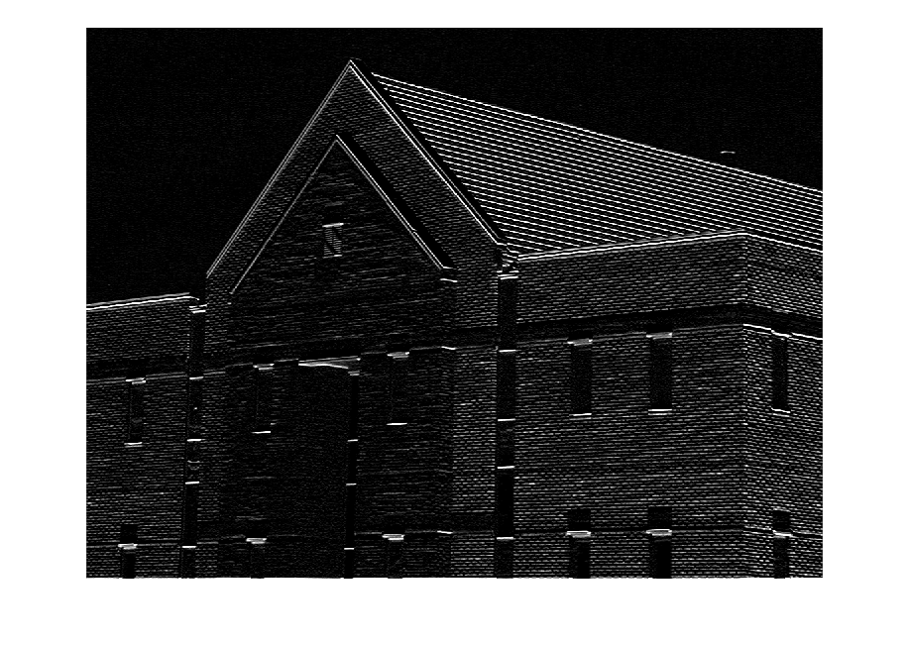

* 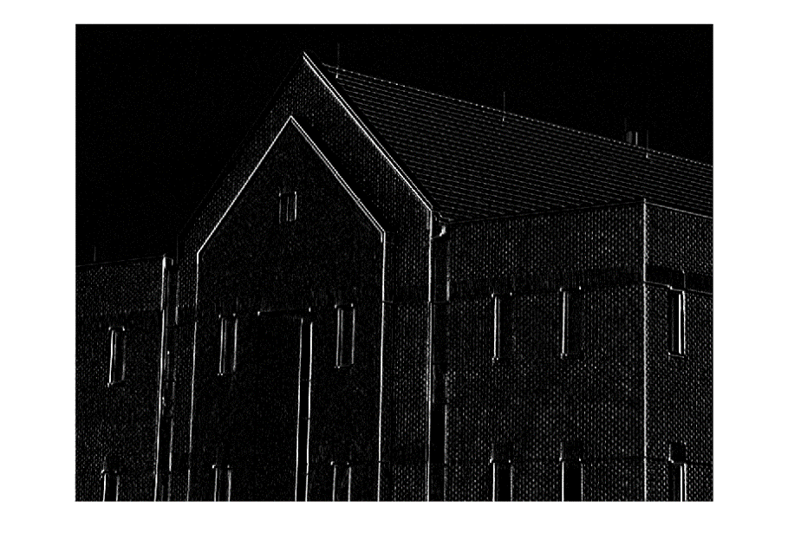**Gradient in y direction:**
* **Magnitude of Gradient:**

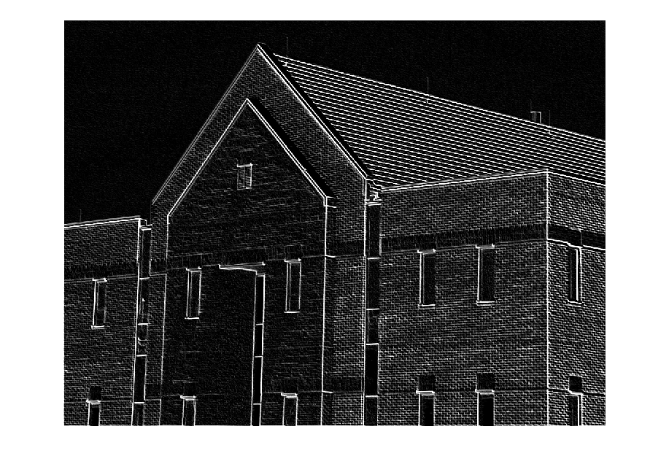

**Q. 3: Implement Otsu’s Method to segment ‘balloons.jpg’ and compare your result with the in-built function graythresh(Image). If both implementations give same result ‘ThumbsUp.jpg’ should be displayed otherwise ‘ThumbsDown.jpg’ should be displayed.**

* **Code:**

|  |
| --- |
| clear all;  img = imread('balloons.jpg');  img = rgb2gray(img);  [m, n] = size(img);  values = linspace(0, 255, 256);  hist_array = imhist(img);  figure;  imshow(img);  min = 99999999;  min_index = -1;  for i = 2 : 254  left = hist_array(1 : i);  right = hist_array(i+1 : 255);  wl = sum(left) / (m * n);  wr = sum(right) / (m * n);  ml = sum(dot(left, values(1:i))) / sum(left);  mr = sum(dot(right, values(i+1:255))) / sum(right);  vl = sum(dot(power(values(1:i) - ml, 2), left)) / sum(left);  vr = sum(dot(power(values(i+1:255) - mr, 2), right)) / sum(right);  within_class_var = wl * vl + wr * vr;  if within_class_var < min  min = within_class_var;  min_index = i;  end  end  for i = 1 : m  for j = 1 : n  if(img(i, j) < min_index)  output(i, j) = 0;  else  output(i, j) = 1;  end  end  end  figure;  imshow(output);  L = graythresh(img);  new_img = im2bw(img, L);  figure;  imshow(new_img);  if(output == new_img)  figure;  imshow('ThumbsUp.jpg');  else  figure;  imshow('ThumbsDown.jpg');  end |

* **Output:**
* 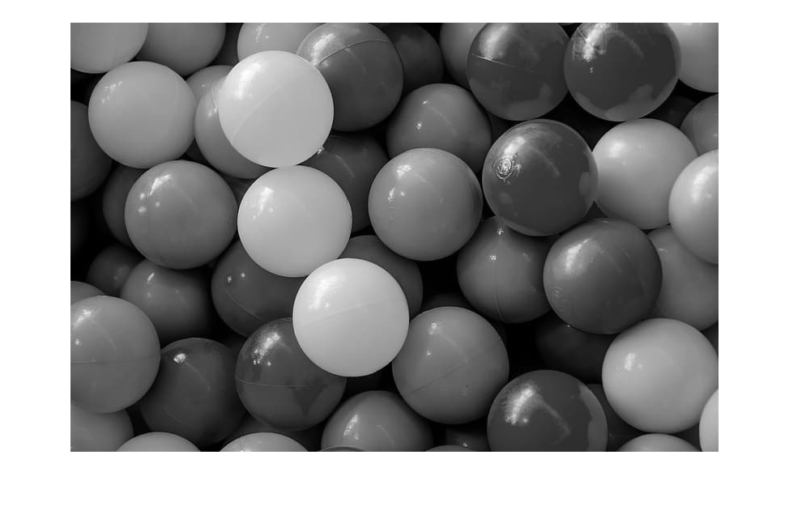**Original Image:**
* **Otsu Implementation:**

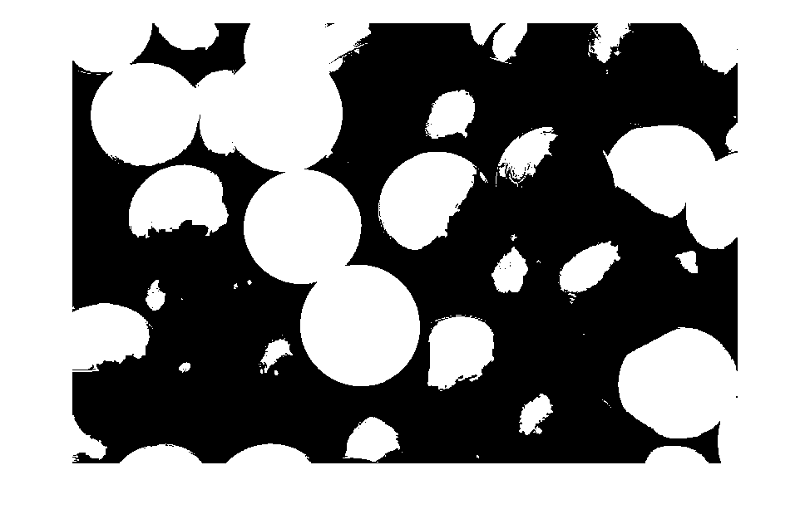

* **In-built function:**
* **Comparison:**

